Software engineering logbook

Contents

**No table of contents entries found.**

# 29/09/22

Today we first had a small discussion on the roles that each of us would be taking. Afterwards we was going through our coding standards to determine how we will be developing the program as a group so that we have a common understanding in the development process so there isn’t any confusion. The first thing that we decided on for the coding standards was the naming conventions which helps us name better then we decided to use some simple concepts. We also set up the discord so that we may communicate between each other as it would be the best tool of communication due to its simplicity and great features.

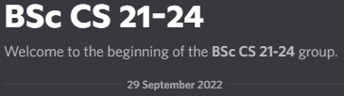

# 30/09/22

On this day we had decided to make official the decisions from yesterday and finalized the assigned roles and coding standards so that we could be ready for when we needed to start working on the project. Not much else happened as we did not have the files yet.

# 03/10/22

Today we have been given the assignment files and have started our planning of the planning from the information that we have been given. Even though we have decided that the design of the UI will be very important to start at an early stage we currently don’t really have any designing apps that we all use which could streamline the design process.

# 05/10/22

Today we have decided to start the early stages of the design process for our project. The first things that we had decided to do as part of our initial design was to start the first user stories which is used to represent how people would actually want to utilize the software.

# 14/10/22

Today we decided to start creating the initial designs for our prototype which is what we will be basing our final design after as, it’s a really good way to do this especially in PowerPoint. The main reason for this being that you can more easily create your own C# frames from this plus, it helps when trying to show of the design to get some well needed feedback.

# 16/10/22

On this day our lead designer used the prototype as a reference for creating the basis of the guest login screen which will be used when a user would like to check the program without a login. And there is also the work in which he performed on the login screen which is used to login to the program.

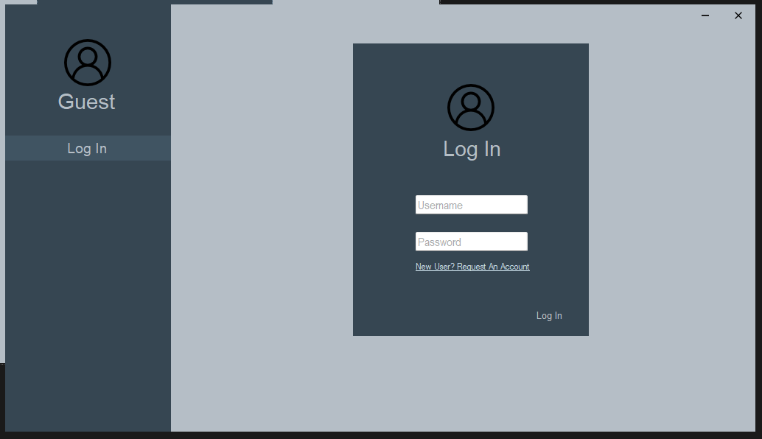

# 17/10/22

Started the sequence diagrams. With these being necessary for

# 18/10/22

Our lead developer decided to sort out the investment product class which as can be seen here is used to be able to import the product details so that the products may be imported from the database allowing for the user functions to work better. This was based on the use case diagram which we used draw.io to create due to its simplicity being free and browser based so it runs on anything basically.

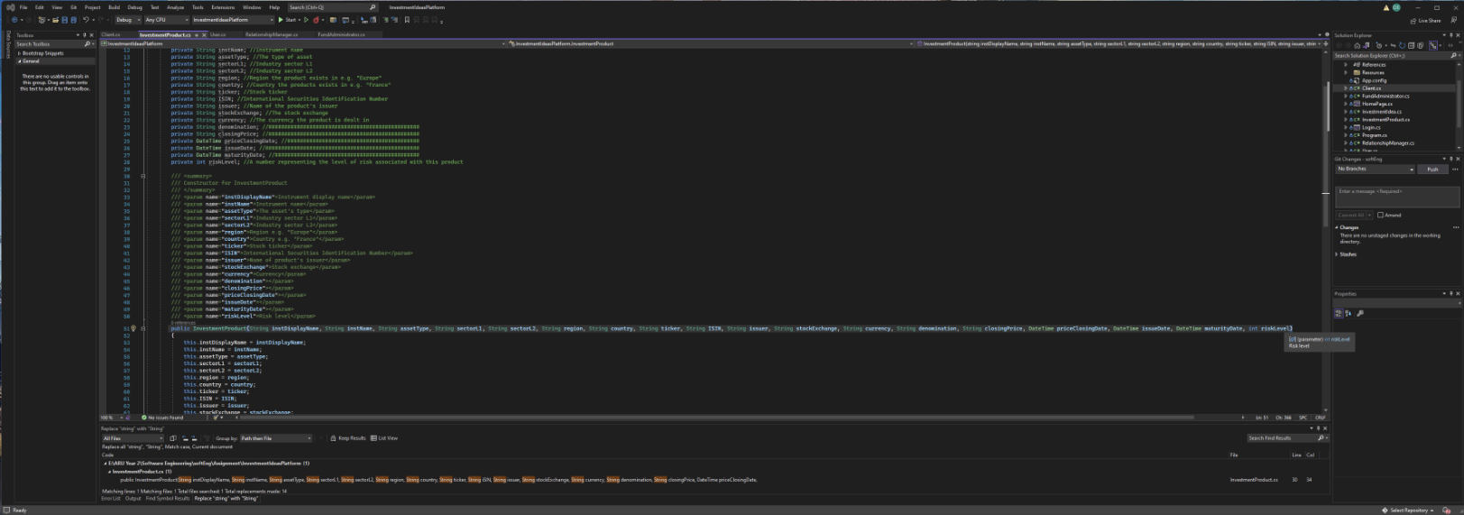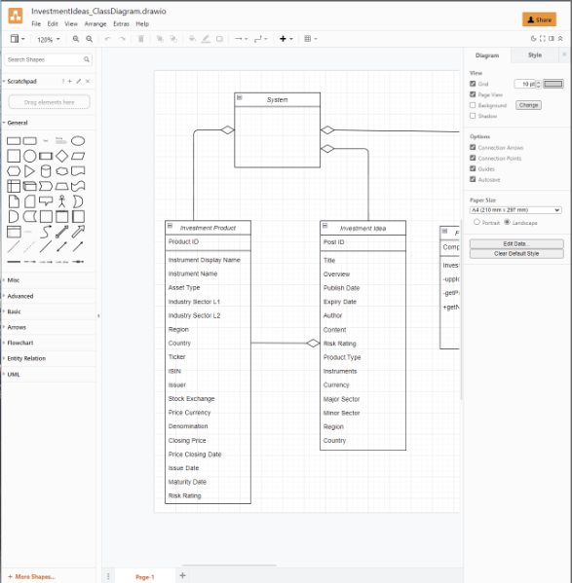Our lead developer also addedthe unit testing for the program so that we can check if specific parts of the program are working or not. This will be done in a separate folder inside of the assignment folder im sure I wont forget about that when making a new test.

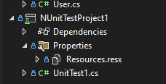

# 19/10/22

On this day our lead designer decided to put more of the framework behind the homepage via the usage of a form of ruler on the left side of the page so that he can decide the perfect placement for all of the assets.

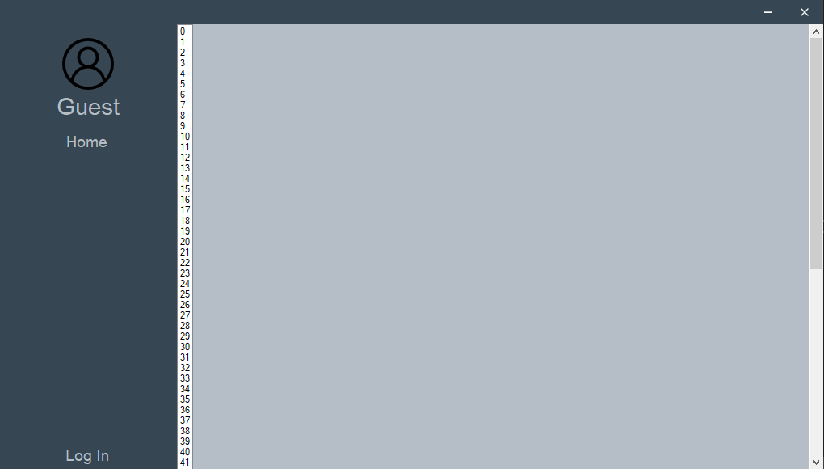

# 20/10/22

Our lead designer had decided to put more work into the colour scheme of the project which makes it feel a lot better to use and in general is a great improvement to the UI and makes it look much better and more corporate.

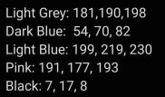

Our lead developer decided to spend a decent chunk of this day on photoshop forming our logo which is a pretty clean or corporate design with smooth edges that glide like butter, a font so clean you could eat dry cornflakes on it and a colour pallete so juicy you could almost mistake it for a smoothie.





# 31/10/22

Today we have decided to have our first main meeting where we presented our prototype to the tutors showing how the test program is supposed to work. One of the main pieces of feedback that we have received being that it looks a lot better as full screen. After that our main designer was working on the colour pallete. Plus he was creating frames from the prototype with one main difference between the prototype and the program being a background given to the description with the same colour as the dark part which made it feel better as we had decided.

# 01/11/22

Our lead designer put some more work into the design of the RM with most of that effort going towards his stylish but subtle decisions with the home page the colour pallette is like a whisper from the wind as its grace meets your eyes, the subtle contrast will put chills down the spine of the bravest investor when they see that page they know you mean business, it’s the hook line and sinker to pull you in for some fantastic financial deals.

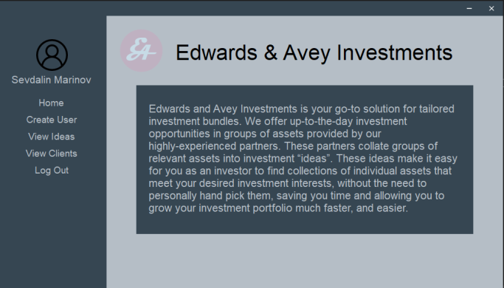

Another thing that he utilised would be a single entry for buttons to make the creation of panels far more efficient greatly improved and as a wise man once said gotta go fast.

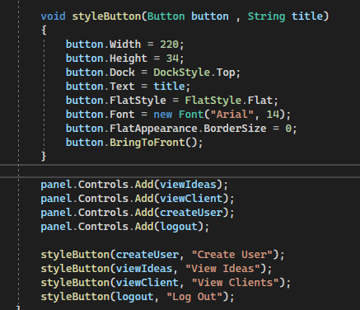

# 02/11/22

Today I had decided to first by using the draw.io desktop application so that I could form the ERD for the database. After that I had decided to start creating the database in DB Browser for SQLite which is a very simple piece of database creation software once you get your head around it which is very helpful. The parts that have been added so far into the database is the investment idea and the investment product. The investment ideas are the individual stocks and options which the user would be able to invest into, whereas the investment products are the groups of those investments stored so that they could be managed easier by the RM.

# 09/11/22

Today I have done some more work on the database but due to some GITHUB conflicts we had to deal with some messy stuff to get the new database of the separate branch so that we could be able to get the branch I have been working on to merge with the main branch. Another part of this was that I had to delete the local files then pull from main so that I could fix the typos in the database.

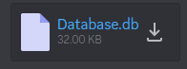

# 10/11/22

Held a scrum meating to assign weekend tasks. In this meeting we decided that I would be creating the database which is the backend of the file system and where all of the user information, investment products and investment ideas will be stored. The way that the user info is stored is as 3 separate table with one for each. Whilst the lead designer decided to try to sort out database connections so that the program may be able to send/receive vital information. Whilst the lead developer was given the task to add the functionality in the user classes which requires the database connections to function.

# 12/11/22

Today I have decided to spend most of the day getting the sql script for ingesting data to work. This was a bit of a major mess and I never ended up getting the script to work on this day. The thing I did get working on this day was having a good structure for the database working. I mean what’s the worst that could happen it’s only a simple sql injection shouln’t be too bad right teehee.

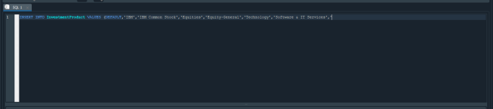

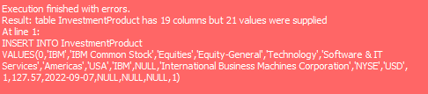

# 13/11/22

Managed to get the sql ingestion but sheesh this is gonna be a hefty one yeah lots of issues to say the least but yeah it works now and I got the information into the database. After doing more than enough typos to sink the titanic I managed to partially import some of the products which then cause a boat load of issues because I didn’t place the semicolons at the end of each line also, I didn’t notice some of the data was entered into the database which meant the sql wouldn’t run. After sorting that out I realised that the issue with the code was that I missed a single variable on one of the entries.

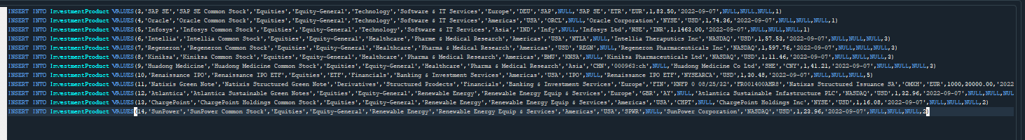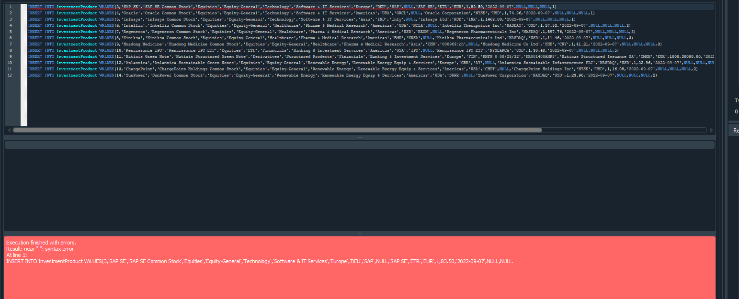

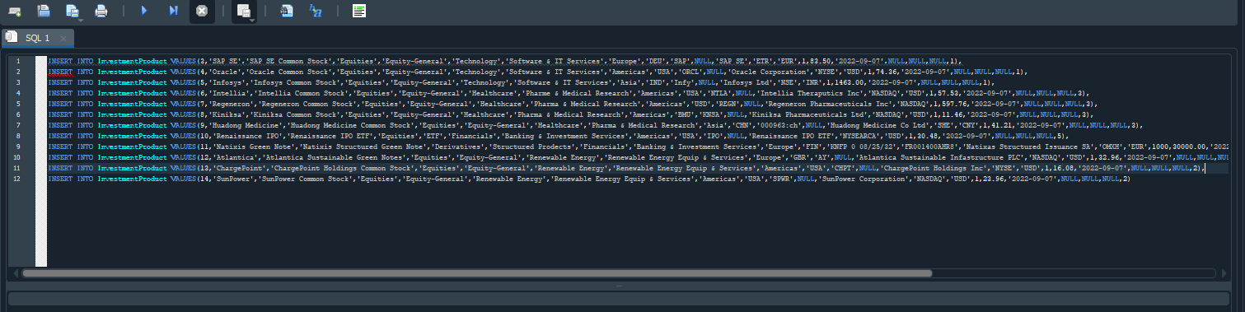

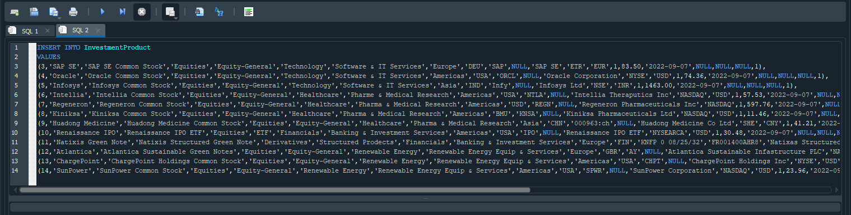

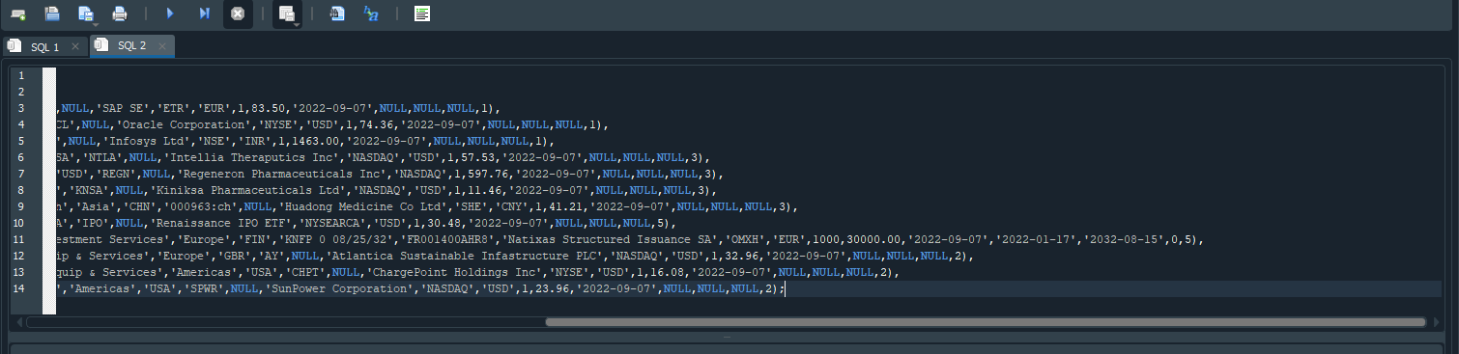



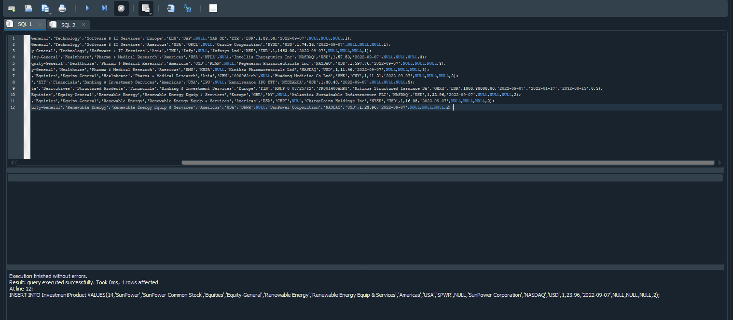

Whilst this nightmare was going on our lead developer was sorting out the functions in preperation for the dbconnections.

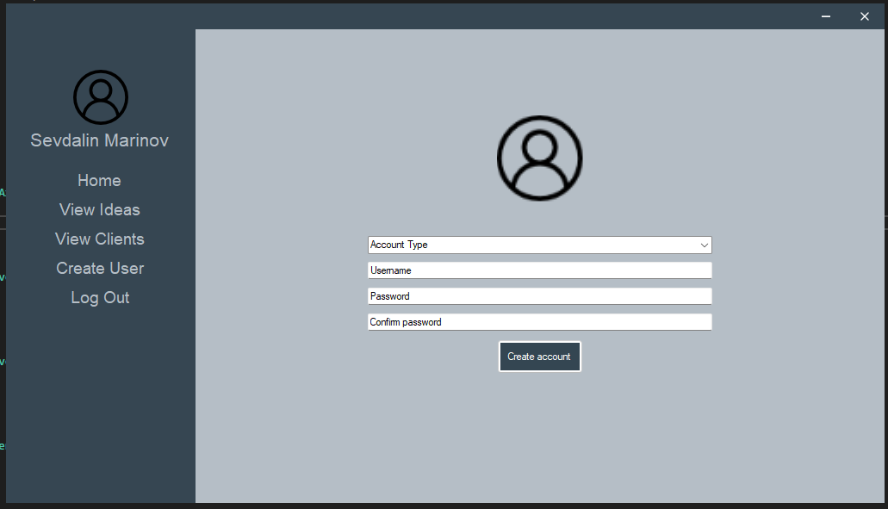

Well that was a mess databases can’t get worse than that right? Time to chill.

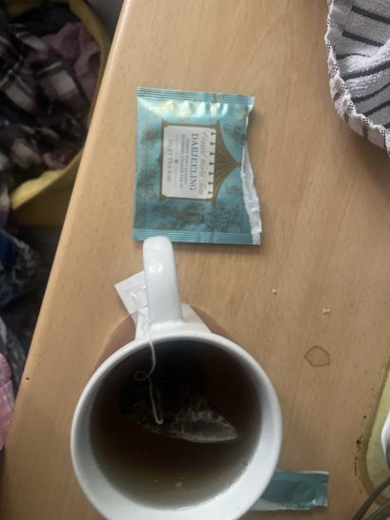

Whilst I was dealing with that mess our lead developer was creating the create user page and deciding whether or not to have a confirm password part so that it would be very difficult to put a typo twice in a row although nothing like that is out of reach for a developer like me.

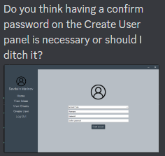

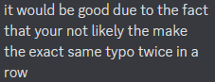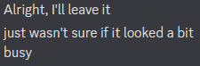

Then he decided to make it so that it would hide the password as you type it in so that it would be sneaky and less grabbable.

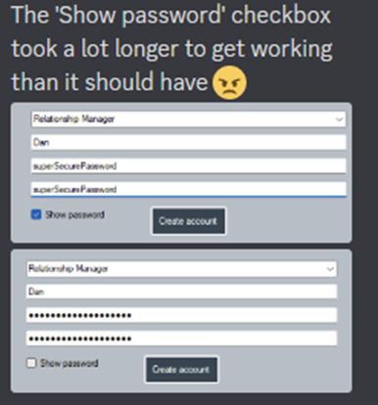

# 14/11/22

Discussed database connectivity options, assigned a task for the week (fully implement the database connectivity) with this being one of the most vital parts of the program given that without it all of the vital functionality of the user classes would not be able to function properly.

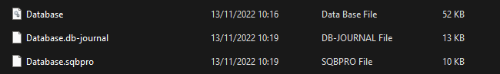

# 16/11/22

Throughout this we have been utilizing a lot online reasources to supplement our limited knowledge on c# that has been really helpful whilst working on this.

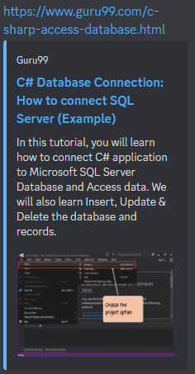

# 17/11/22

I had decided to do check over the database and check out some microsoft documentation which helped quite a bit as they have some decent developers over there.

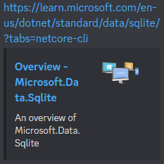

# 18/11/22

Decided against a DB factory in favour of SQLite connectivity only due to the fact that we are only using a sqlite database to store all of the files. The main reason to have it this way is so that there is a lot less redundant code in the program allowing it to be more lightweight. However it did not go without issues as there was a small string issue which we tried to fix within the properties.dat file.

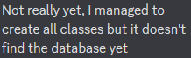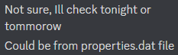

# 19/11/22

On the next day I checked in to see how the connections was doing so that I could try to implement some users into the database through the usage of the create user function.



# 20/11/22

For some wild reason I placed the wrong date in the logbook I have no idee why I did this.

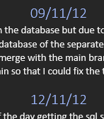

Whilst I was having a brain fart our lead developer was having issues with the database so I stated that I would try and help him later on monday with help from my documentation.

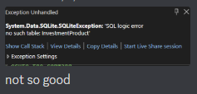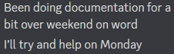

# 21/11/22

DB connection fully implemented and tweaked use case diagrams to reflect RMs as the sole creators of new accounts. Doing it this way makes the account type roles much more well defined allowing for the program to be more simple and streamlined. This allows for the functions to truly be able to connect to the database.

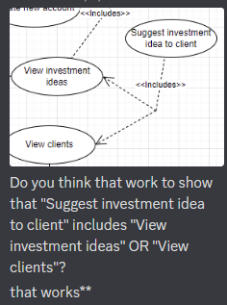

# 22/11/22

Our lead designer was going to do some changes to the login page however our lead developer was some funky little tweaks to the login page which made it look a lot nicer in my personal opinion pretty decent if you’d ask me dude.

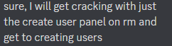

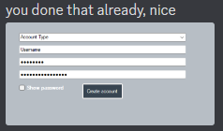

He also had some issues with the DbDataReader specifically the SqLiteCon.initialize()

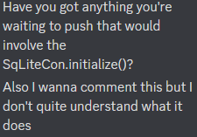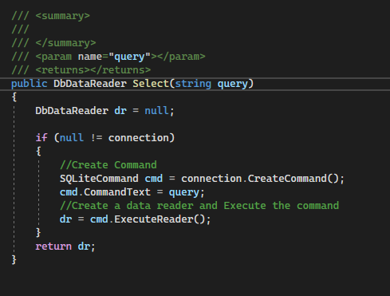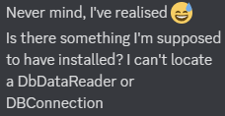

# 23/11/22

Discussed ways to streamline program by eliminating redundant classes, redesigned database and implemented database redesign. Making the program run a lot smoother and removing the unnecessary wasted code.

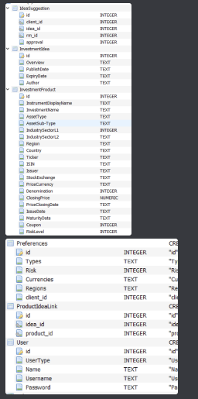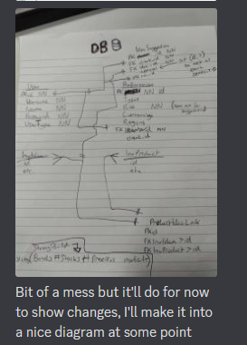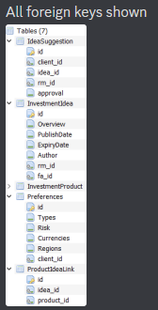

# 25/11/22

Finalised reformatting the classes removing the RM and Fa classes and the panel functions from Client so that it could all be in the UIManager class with a switch loop to decide between the 3 usertypes. This allows for the program to be much more streamlined as it not only cuts out 2 of the classes to be culled, this also allows for a major reduction of redundancy in terms of shared functionality. They also worked on the DBConnection / Factory and a little bit of the SqLiteCon.

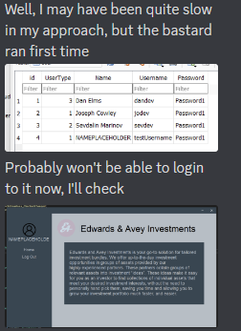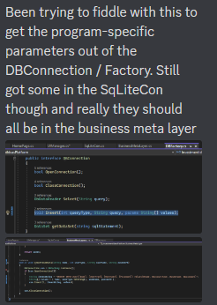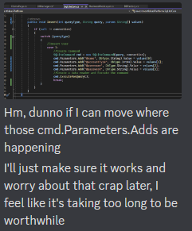

# 29/11/22

Implemented filters on RM >View ideas, RM> View clients, Client>view suggested ideas, Client>Edit profile and FA>Create idea which is so that you can create ideas from within the program and don’t have to directly enter it via the database. This makes it so that that it is much easier to add those entries and is vital for the functionality.

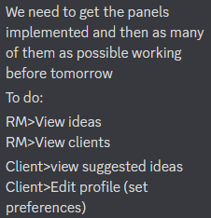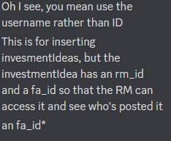Whilst that was happening I was enquiring the other fellas about the powerpoint so that we could all be on the same train of thought.

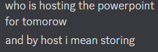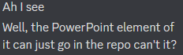

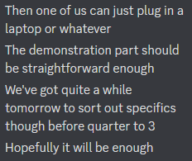

We also discussed the database which was rather helpful.

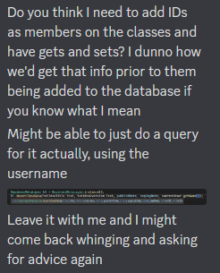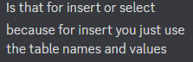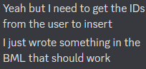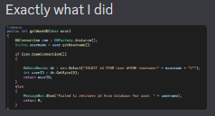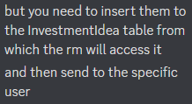

# 30/11/22

So today was the day of the presentation and it went ok however the client had some large but fair criticisms. We also heavily rushed it due to some poor time management near the end which meant that a lot of the things was in the wrong place and it was a bit scuffed to say the least.

Lead Developer Lead designer Manager

